**Mauby**

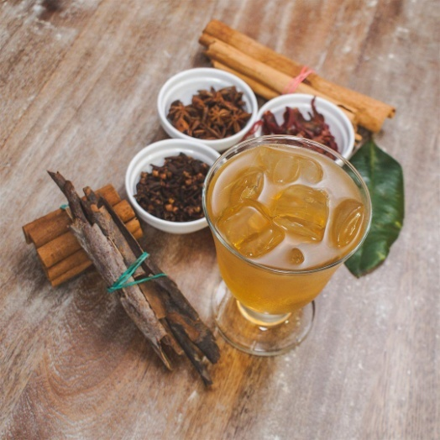

Mauby is one of the most popular, if not the most popular drink across the Caribbean. It is as polarizing as it is popular. receiving strong emotions on both ends of the spectrum, you either love it or hate it. Mauby is made from the bark of the tree known as Colubrina Elliptica, Mabi or Soldierwood.

**INGREDIENTS**

3 pieces of mauby bark

1 piece of cassia cinnamon (one inch)

1 piece of dalchini cinnamon (two inch)

3 star anise

2 tsp aniseed

1 tsp whole clove

2 pieces of mace

1 large bay leaf

1 cup brown sugar (or to taste)

8 cups water

**METHOD**

Bring water to a rolling boil then add spices

Reduce heat then allow to simmer for 15 minutes

Sweeten with brown sugar then allow to cool

Strain and transfer to a jug

Serve chilled or over ice

Enjoy!